**Nutrition habits survey**

This is a very extensive study that was done by creating a focus group that consisted of 112 people from different background, age, and gender around the United States. The study is mainly going to take aim at those responses coming from people who take supplements, even though we may occasionally rely on the responses of those people who do not take supplements.

1. **The vast majority of the population take supplements.**

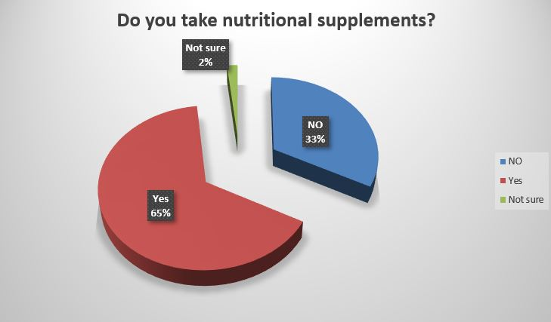

Out of 112 people that were polled, we found out that, surprisingly, the majority, which represents 65% of people polled, actually take nutritional supplements, whereas 33% of the people do not take nutritional supplements, and only 2% of the people polled were not sure about this question.

1. **More women take supplements compared to men.**

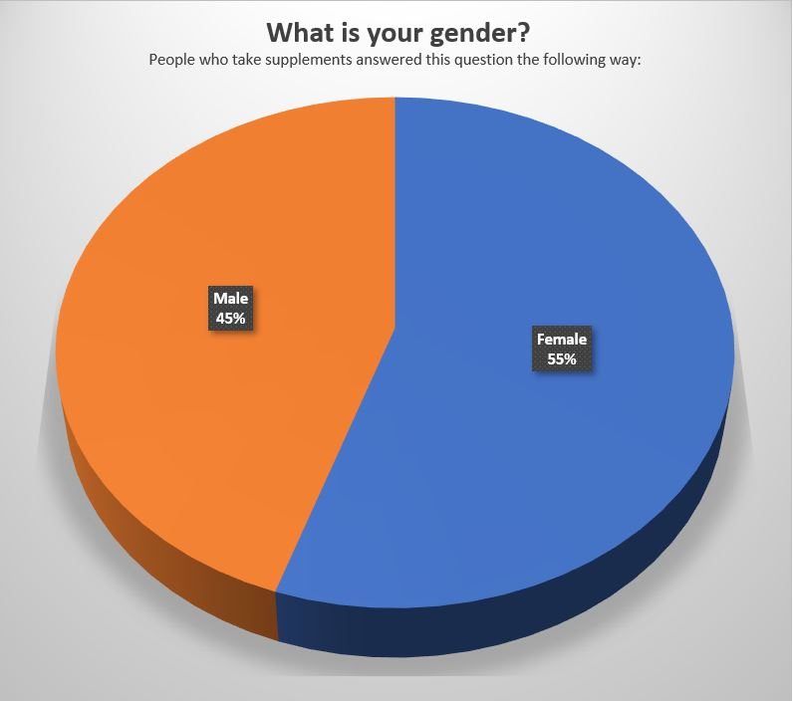

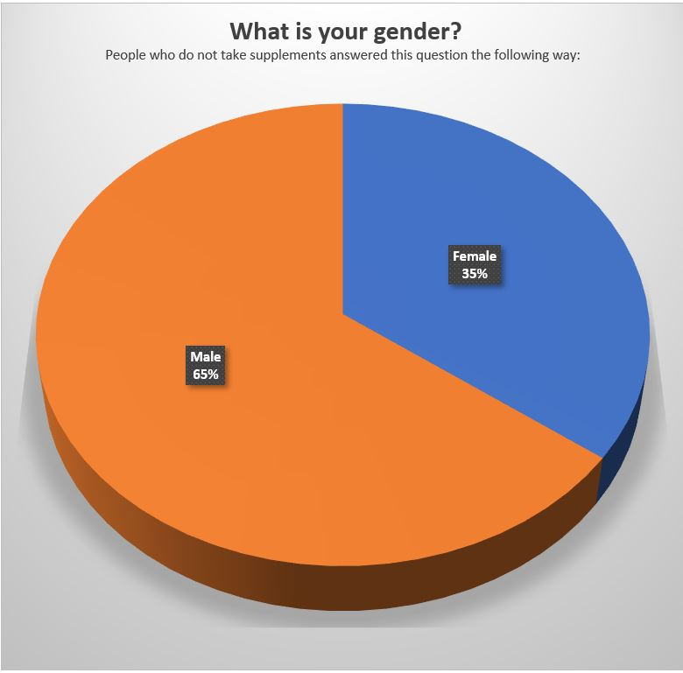

Based on our study, and as we said before, this part only focuses on the people who do take supplements which is 65%. Out of 65%, the vast majority of people who take supplements are women (55%), when it comes to men, out of the 65% of the population that takes supplements, 45% of the male take supplements.

Now, to contrast those number on the other side, as stated above, we found that 33% of the entire population does not take supplements, we found that the vast majority of the population that population, 33%, are men. This means that 65% out of the 33% do not take supplements, whereas the minority of these people are women. Women represent 35% out of 33%.

1. **The internet is the main source of information people rely upon when it comes to learning information about nutrition.**

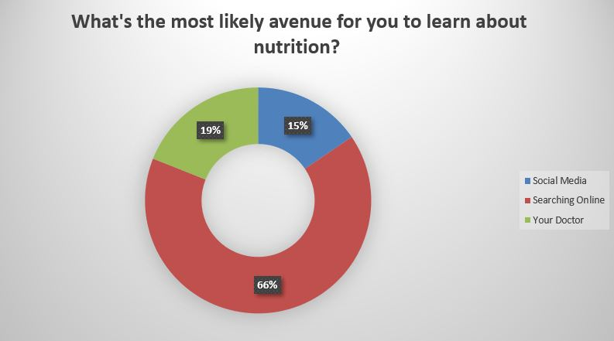

We found that based on the samples taken from this extensive study, a significant majority of people, 81% out of the 65% of people that take supplements, rely on the internet to educate themselves about nutrition and supplements, in general, this includes online searches and social media. If we breakdown the online “world” into two parts, meaning, social media and people searching online on their own, then we can see that the percentages are a split of 15% and 66% respectively. On the other hand, 19% of people prefer to learn about nutrition directly from their doctor.

1. **The internet is the main avenue for people to search for information about nutritional supplements.**

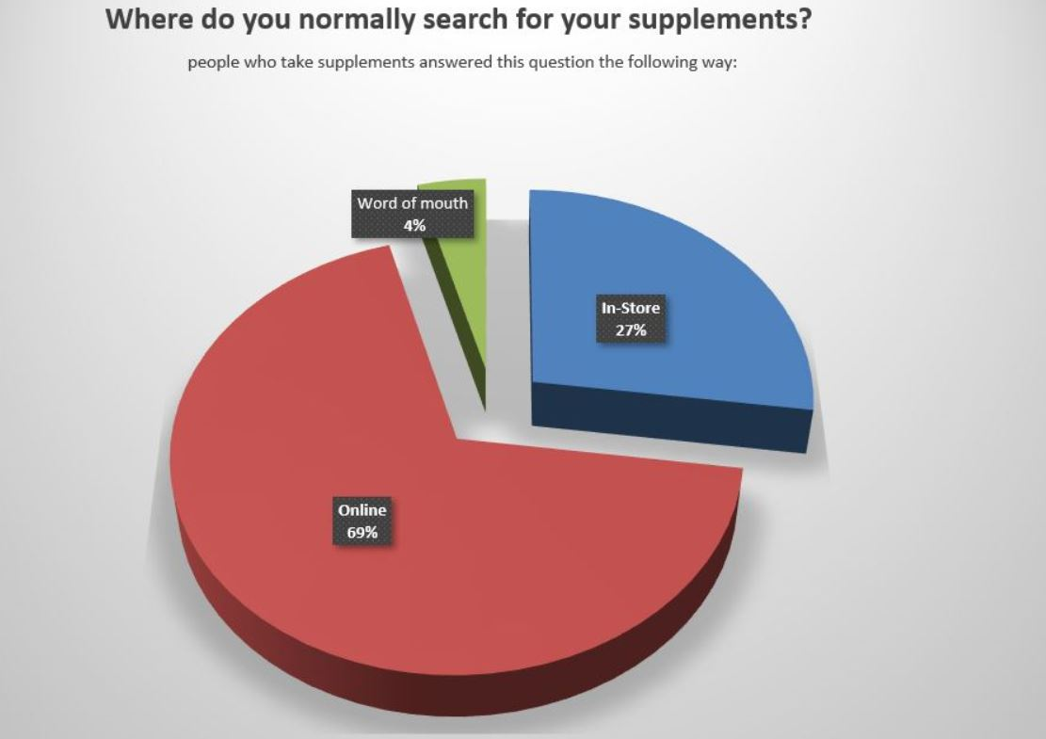

Out of the 65% of the population that take supplement, 69% of people prefer to search for information online about specific details that they are interested in. That means that a very little minority usually prefers to find out by asking other people (word of mouth, 4%), or by going to a store (27% out of the 65%).

1. **The price is the main concern of people when they look for a supplement.**

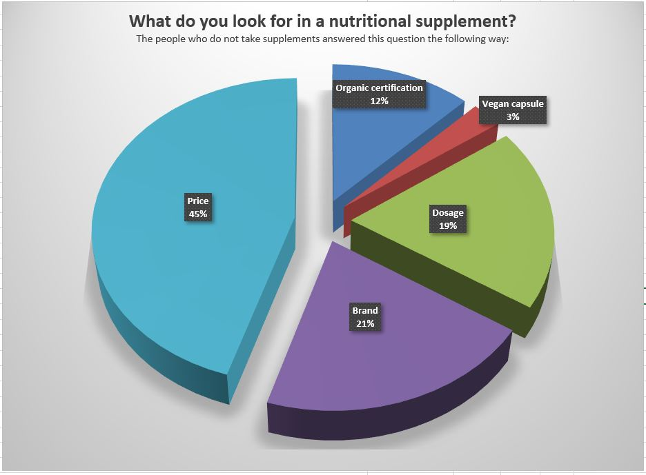

Based on our studies, 45% of people out of the 65% population that take supplements are more concern about the price than anything else. 21% of people out of the 65% are more concerned with the brand whereas 19% of people care more about the dosage amount, 12% are interested to know if the product contains an organic certification, or if the product is vegan 3%.

1. **Some people are likely to try a supplement that they read about in the news.**

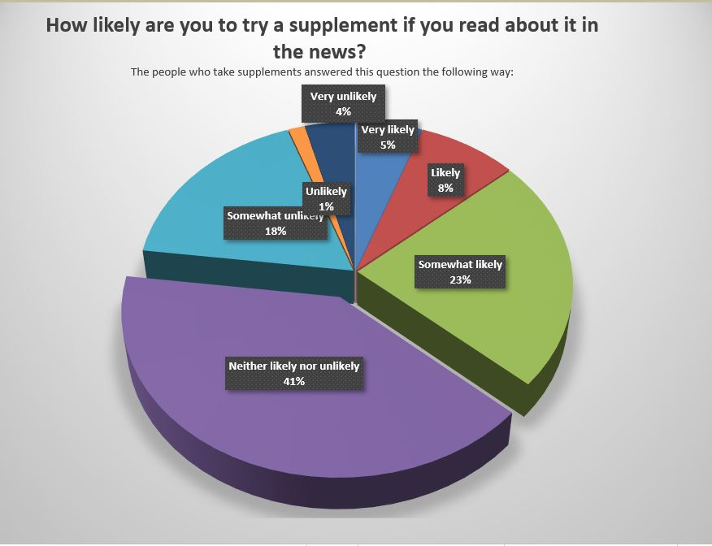

Based on the population that takes supplements (65%), 36% of people are likely to try a supplement that they read about in the news. However, this number ought to be broken down in several pieces. 23% of the 36% are somewhat likely to try a supplement that they read about in the news and 8% of people are likely to try where only 5% would be very likely to try supplements that they read about in the news.

This number is contrasted by 23% that will likely not take supplements that they read about in the news. This leaves a sweeping 41% of people that may or may not try a supplement that they read about in the news.

1. **A large majority of the population has not heard of Moringa Oleifera.**

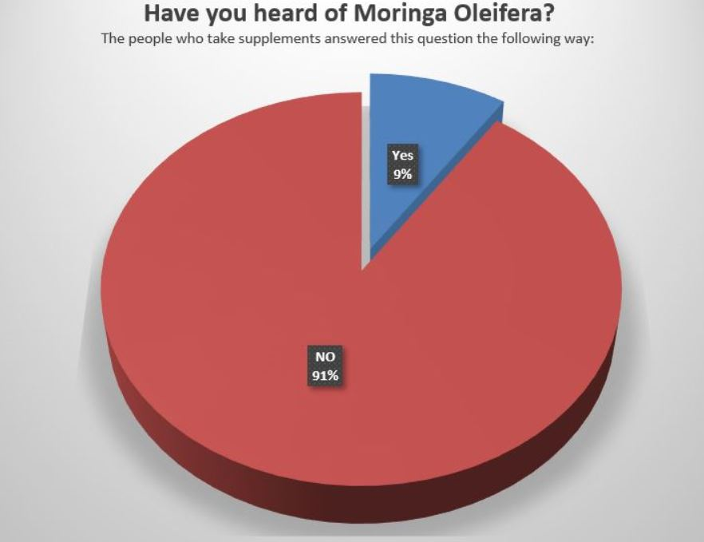

It was found in this study that the vast majority of people that take supplements have not yet heard of Moringa oliefera, this number peaks a height of 91%, amongst the 65% of the population that take supplements. On the other hand, only 9% of people that take supplements have actually heard about Moringa oliefera.

1. **The people who heard about Moringa Oleifera did so through online searches.**

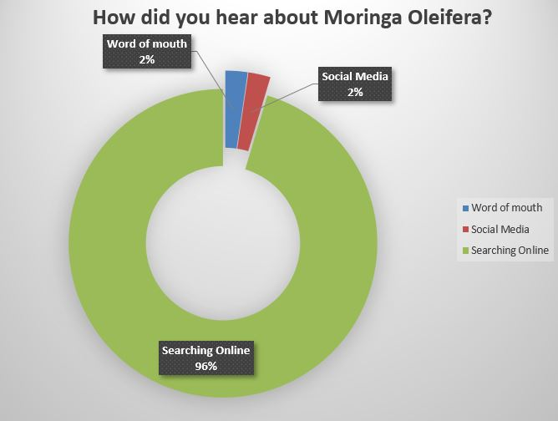

Based on the entire sample population, including people who take supplements and those who do not, we found that 98%, of the 7% that have heard of the product in general, have heard about the product by searching online (96%) and Social media (2%). On the other hand, only 2% of the people who have heard about Moringa Oleifera, heard about the product by word of mouth.

**Conclusion:**

Our findings show that the vast majority of the population take supplements. Based on that majority, more women are likely to take supplements compared to men. We also found that the internet is the main source of information people rely on when it comes to learning information about nutrition, whereas the internet is also the main avenue for people to search information about nutritional supplements as well.

When it comes to purchasing or considering buying a nutritional supplement, the price is the main concern of people when they look for supplements, also some people are likely to try a supplement that they read about in the news, even though there is caveat to that number since a large part of the population may or may not try a supplement that they read about in the news.

When it comes to the product “Moringa Oleifera” a large majority of the population has not heard of this product and the people who heard about Moringa Oleifera did so through online searches. This makes the internet the main source for not only information that people use in order to learn about nutrition, its benefits and so on.